Supplementary Material

PART A: MODEL FITTING

Bayesian ordinal model fit plots were generated using the built-in brms tool pp_check (Bürkner 2018). Fitting for logistic binomial GLM plots was done using performance (Lüdecke et al., 2020) for generating binned residuals and plots and see for plotting (Lüdecke et al., 2020).

Part 1: Model Fitting

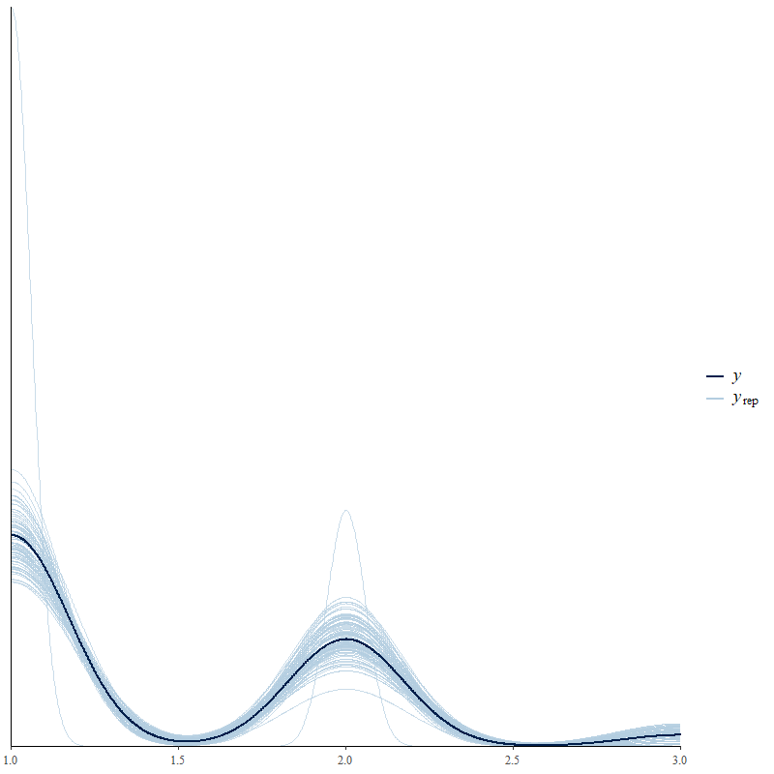

Supplementary Figure 1. Safety Model Plot: Observed data (dark blue line) and modelled data (light blue lines).

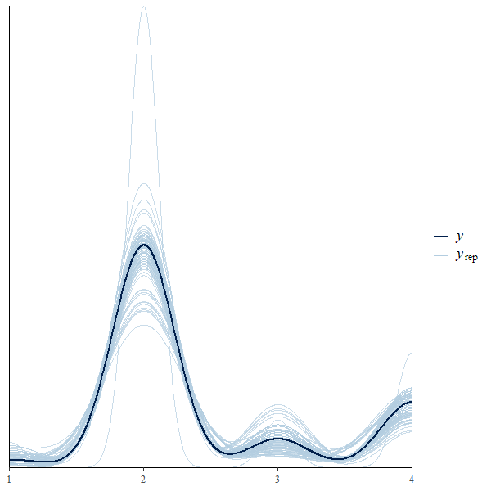

Supplementary Figure 2. Changes in General Safety Model Plot: Observed data (dark blue line) and modelled data (light blue lines).

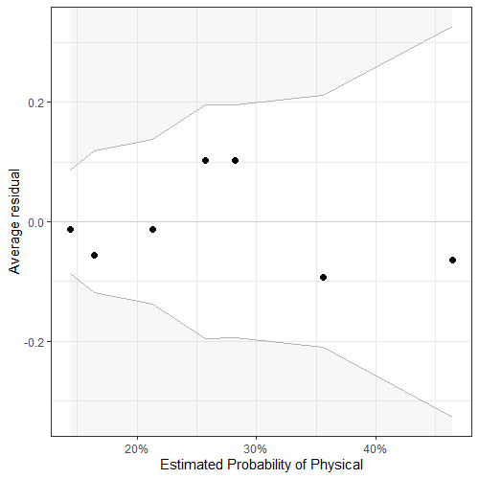

Supplementary Figure 3. Specific Safety Concern Physical Model Plot: About 100% of the residuals are inside the error bounds (white area).

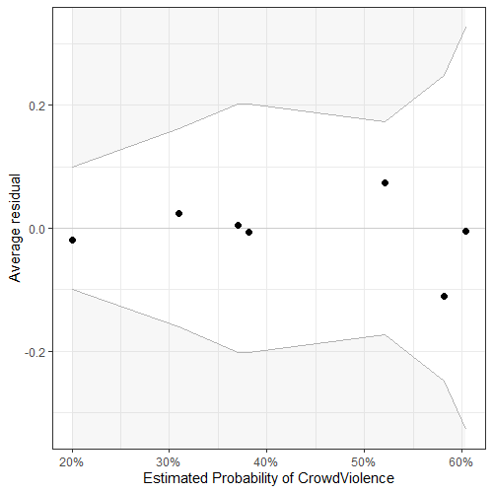

Supplementary Figure 4. Specific Safety Concern Crowd Violence Model Plot: About 100% of the residuals are inside the error bounds (white area).
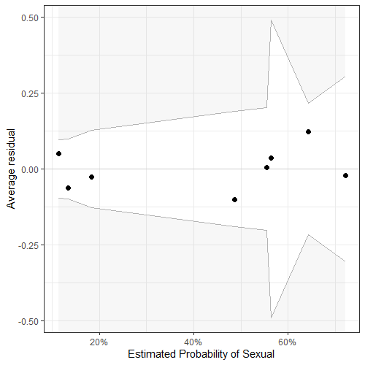

Supplementary Figure 5. Specific Safety Concern Sexual Model Plot: About 100% of the residuals are inside the error bounds (white area).
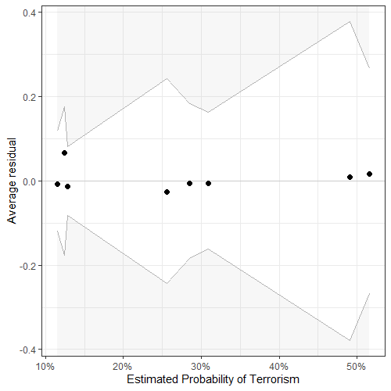

Supplementary Figure 6. Specific Safety Concern Terrorism Model Plot: About 100% of the residuals are inside the error bounds (white area).

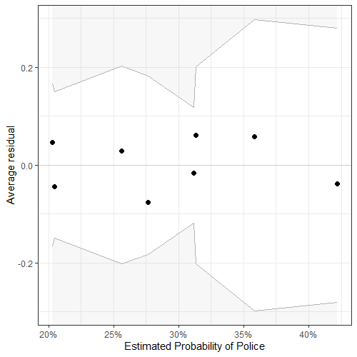

Supplementary Figure 7. Specific Safety Concern Police Model Plot: About 100% of the residuals are inside the error bounds (white area).

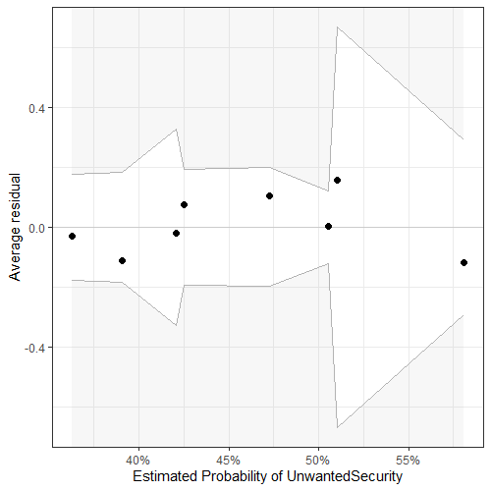

Supplementary Figure 8. Specific Safety Concern Unwanted Security Model Plot: About 100% of the residuals are inside the error bounds (white area).
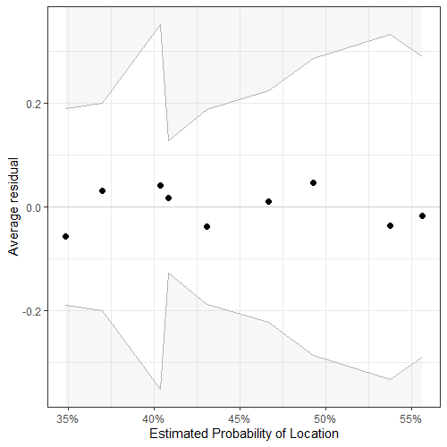

Supplementary Figure 9. Safety Measures Location Model Plot: About 100% of the residuals are inside the error bounds (white area).

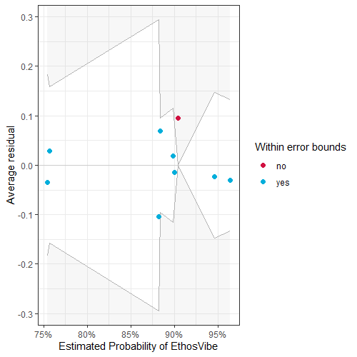

Supplementary Figure 10. Safety Measures Ethos/Vibe/Rules Model Plot: About 89% of the residuals are inside the error bounds (white area).

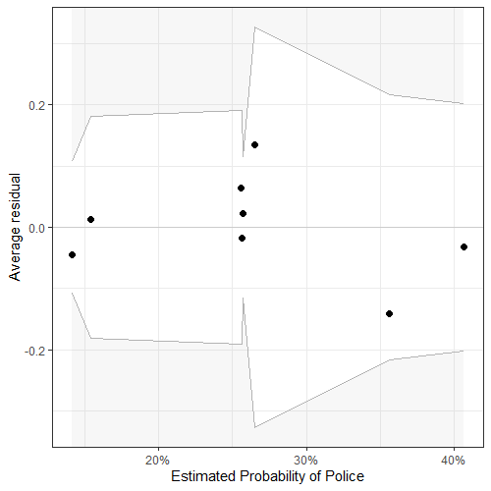

Supplementary Figure 11. Safety Measures Police Model Plot: About 100% of the residuals are inside the error bounds (white area).

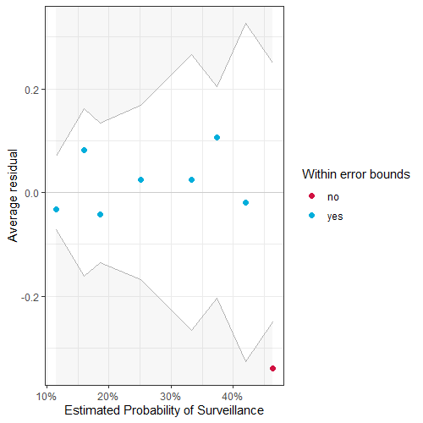

Supplementary Figure 12. Safety Measures Surveillance Model Plot: About 88% of the residuals are inside the error bounds (white area).

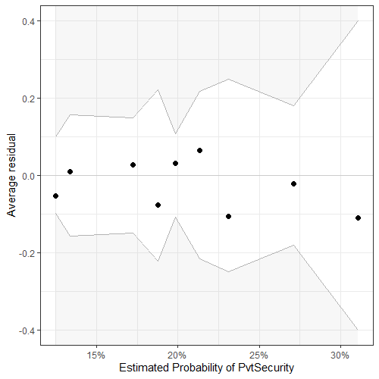

Supplementary Figure 13. Safety Measures Private Security Model Plot: About 100% of the residuals are inside the error bounds (white area).

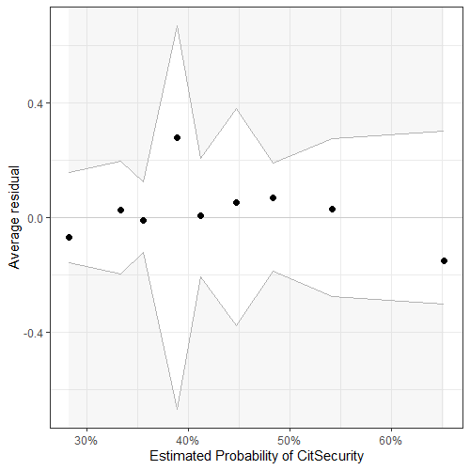

Supplementary Figure 14. Safety Measures Citizen Security Model Plot: About 100% of the residuals are inside the error bounds (white area).

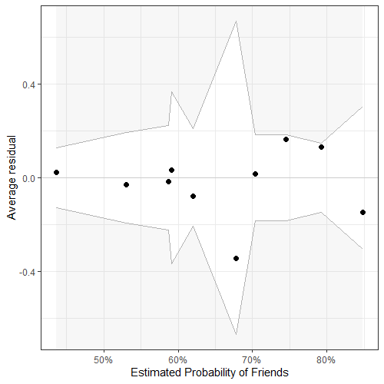

Supplementary Figure 15. Safety Measures Friends Model Plot: About 100% of the residuals are inside the error bounds (white area).

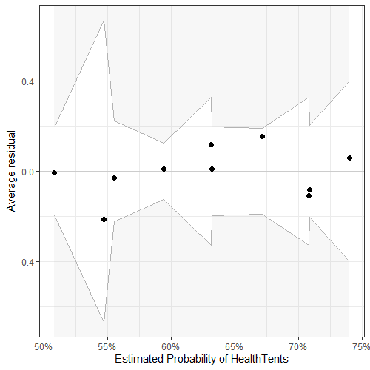

Supplementary Figure 16. Safety Measures Health Tents Model Plot: About 100% of the residuals are inside the error bounds (white area).

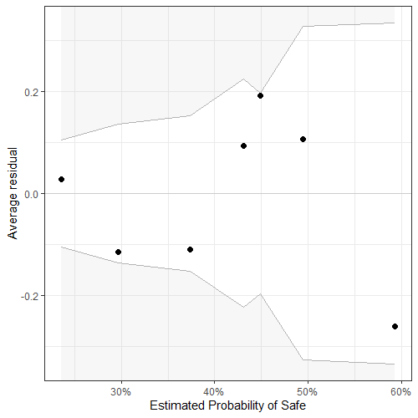

Supplementary Figure 17. Feelings about Surveillance Safe Model Plot: About 100% of the residuals are inside the error bounds (white area).

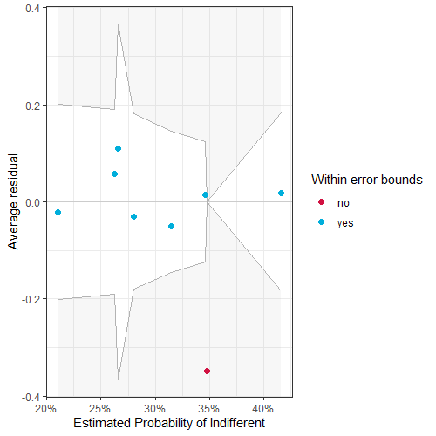

Supplementary Figure 18. Feelings about Surveillance Indifferent Model Plot: About 88% of the residuals are inside the error bounds (white area).

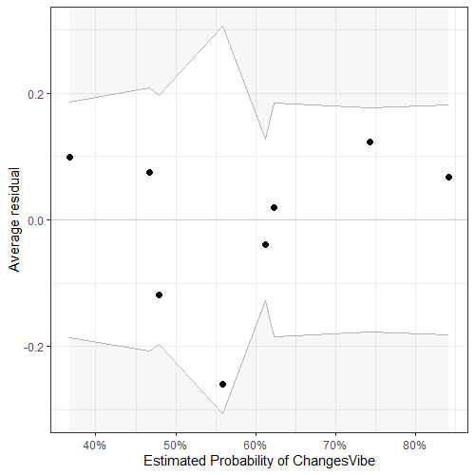

Supplementary Figure 19. Feelings about Surveillance Changed Vibe Model Plot: About 100% of the residuals are inside the error bounds (white area).

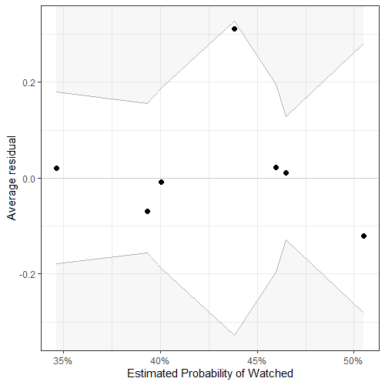

Supplementary Figure 20. Feelings about Surveillance Watched Model Plot: About 100% of the residuals are inside the error bounds (white area).

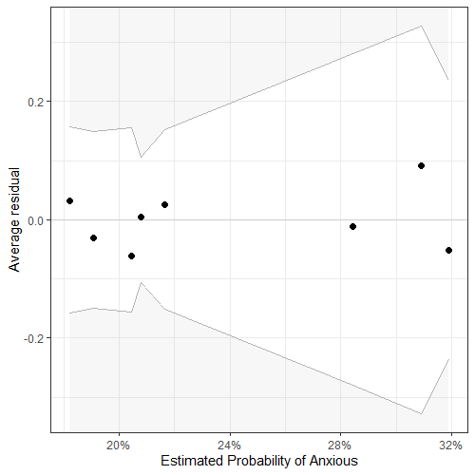

Supplementary Figure 21. Feelings about Surveillance Anxious Model Plot: About 100% of the residuals are inside the error bounds (white area).

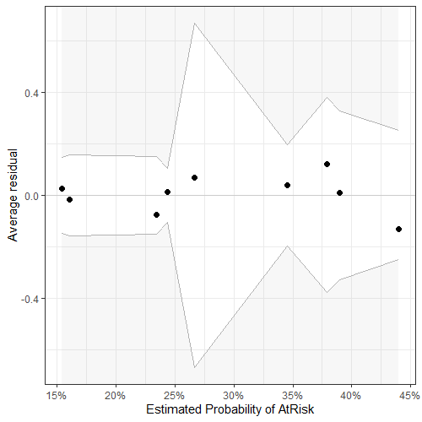

Supplementary Figure 22. Feelings about Surveillance At Risk Model Plot: About 100% of the residuals are inside the error bounds (white area).

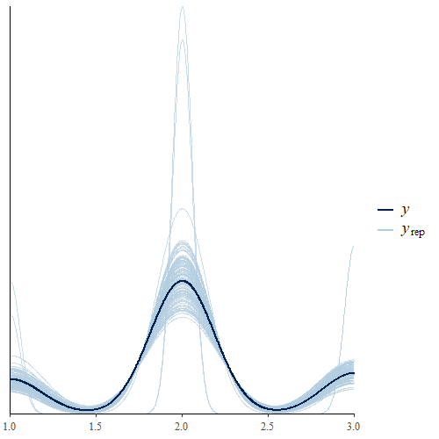

Supplementary Figure 23. Notice Surveillance Model Plot: Observed data (dark blue line) and modelled data (light blue lines)

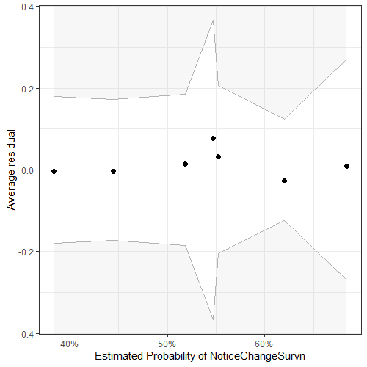

Supplementary Figure 24. Notice Increased Surveillance Model Plot: About 100% of the residuals are inside the error bounds (white area).

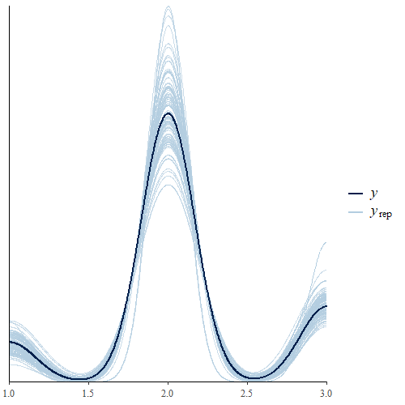

Supplementary Figure 25.Need for Less/Same/More Surveillance Model Plot: Observed data (dark blue line) and modelled data (light blue lines).

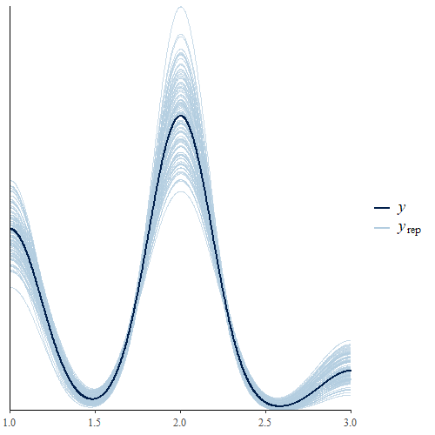

Supplementary Figure 26. Inclined to Attend if Surveillance Model Plot: Observed data (dark blue line) and modelled data (light blue lines).

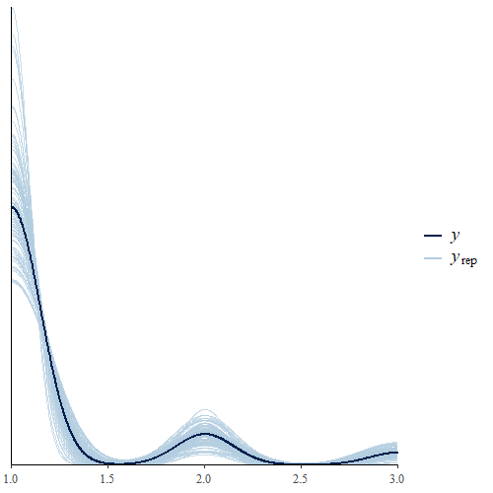

Supplementary Figure 27. Declined to Attend due to Feeling Unsafe Model Plot: Observed data (dark blue line) and modelled data (light blue lines).

PART B: FULL RESULTS

Supplementary Table 1. Full results for all models. Bolded independent factors under main headings have significant results.

 |  | Term | Est | Est.Err | CI-2.5% | CI-97.5%
GENERAL SAFETY CONCERNS
Personal Safety |  | Intercept[1] | -0.37 | 0.28 | -0.93 | 0.16
 |  | Intercept[2] | 2.74 | 0.43 | 1.98 | 3.63
 |  | Experience.L | -0.82 | 0.29 | -1.37 | -0.23
 |  | Experience.Q | -0.22 | 0.28 | -0.78 | 0.32
 |  | SexMale | -1.51 | 0.34 | -2.18 | -0.85
 |  | SexOrientLGBQA | 0.26 | 0.41 | -0.54 | 1.05
Changes in Personal Safety |  | Intercept[1] | -4.22 | 0.54 | -5.34 | -3.19
 |  | Intercept[2] | 0.48 | 0.26 | -0.03 | 0.98
 |  | Intercept[3] | 1.00 | 0.28 | 0.46 | 1.52
 |  | Experience.L | -0.39 | 0.29 | -0.95 | 0.18
 |  | Experience.Q | -0.23 | 0.27 | -0.78 | 0.29
 |  | SexMale | -0.51 | 0.32 | -1.16 | 0.11
 |  | SexOrientLGBQA | -0.45 | 0.44 | -1.34 | 0.39
SPECIFIC SAFETY CONCERNS | % Pop
Physical | 23% | (Intercept) | -0.88 | 0.29 | -1.46 | -0.33
 |  | SexMale | -0.57 | 0.36 | -1.28 | 0.14
 |  | Experience.L | -0.61 | 0.30 | -1.21 | -0.01
 |  | Experience.Q | 0.23 | 0.31 | -0.36 | 0.85
 |  | SexOrientLGBQA | 0.21 | 0.44 | -0.68 | 1.05
Crowd Violence | 37% | (Intercept) | 0.04 | 0.26 | -0.46 | 0.56
 |  | SexMale | -0.90 | 0.32 | -1.53 | -0.28
 |  | Experience.L | -0.61 | 0.28 | -1.17 | -0.06
 |  | Experience.Q | -0.23 | 0.27 | -0.75 | 0.30
 |  | SexOrientLGBQA | 0.04 | 0.41 | -0.77 | 0.83
Sexual | 33% | (Intercept) | 0.32 | 0.27 | -0.19 | 0.85
 |  | SexMale | -2.09 | 0.36 | -2.81 | -1.40
 |  | Experience.L | -0.49 | 0.32 | -1.12 | 0.14
 |  | Experience.Q | 0.12 | 0.31 | -0.47 | 0.73
 |  | SexOrientLGBQA | 0.23 | 0.44 | -0.64 | 1.09
Terrorism | 23% | (Intercept) | -0.85 | 0.28 | -1.41 | -0.32
 |  | SexMale | -1.12 | 0.37 | -1.86 | -0.41
 |  | Experience.L | 0.02 | 0.33 | -0.61 | 0.70
 |  | Experience.Q | 0.09 | 0.32 | -0.53 | 0.73
 |  | SexOrientLGBQA | 0.88 | 0.42 | 0.05 | 1.69
Police | 30% | (Intercept) | -1.07 | 0.29 | -1.65 | -0.52
 |  | SexMale | -0.01 | 0.34 | -0.67 | 0.66
 |  | Experience.L | 0.19 | 0.29 | -0.37 | 0.79
 |  | Experience.Q | 0.36 | 0.30 | -0.22 | 0.97
 |  | SexOrientLGBQA | 0.48 | 0.41 | -0.34 | 1.27
Unwanted Security | 46% | (Intercept) | -0.40 | 0.26 | -0.92 | 0.10
 |  | SexMale | 0.14 | 0.30 | -0.45 | 0.74
 |  | Experience.L | 0.40 | 0.27 | -0.13 | 0.94
 |  | Experience.Q | 0.05 | 0.26 | -0.46 | 0.56
 |  | SexOrientLGBQA | 0.34 | 0.39 | -0.41 | 1.11
MEASURES
Location | 43% | (Intercept) | -0.52 | 0.26 | -1.04 | -0.01
 |  | SexMale | 0.26 | 0.31 | -0.34 | 0.87
 |  | Experience.L | -0.17 | 0.27 | -0.69 | 0.36
 |  | Experience.Q | 0.02 | 0.26 | -0.49 | 0.54
 |  | SexOrientLGBQA | 0.54 | 0.38 | -0.21 | 1.30
Ethos/Vibe | 87% | (Intercept) | 1.77 | 0.38 | 1.08 | 2.57
 |  | SexMale | 0.02 | 0.45 | -0.88 | 0.88
 |  | Experience.L | 0.12 | 0.45 | -0.85 | 0.97
 |  | Experience.Q | 0.80 | 0.37 | 0.09 | 1.53
 |  | SexOrientLGBQA | 1.13 | 0.78 | -0.20 | 3.01
Police | 25% | (Intercept) | -0.61 | 0.28 | -1.16 | -0.08
 |  | SexMale | -0.68 | 0.35 | -1.37 | -0.01
 |  | Experience.L | 0.00 | 0.30 | -0.57 | 0.60
 |  | Experience.Q | 0.56 | 0.32 | -0.04 | 1.22
 |  | SexOrientLGBQA | -0.64 | 0.48 | -1.65 | 0.26
Surveillance | 21% | (Intercept) | -0.76 | 0.28 | -1.32 | -0.23
 |  | SexMale | -0.96 | 0.36 | -1.68 | -0.26
 |  | Experience.L | -0.27 | 0.33 | -0.91 | 0.39
 |  | Experience.Q | -0.30 | 0.30 | -0.89 | 0.29
 |  | SexOrientLGBQA | 0.37 | 0.43 | -0.50 | 1.20
Private Security | 19% | (Intercept) | -1.33 | 0.31 | -1.97 | -0.75
 |  | SexMale | -0.41 | 0.38 | -1.15 | 0.34
 |  | Experience.L | 0.34 | 0.35 | -0.32 | 1.06
 |  | Experience.Q | 0.26 | 0.35 | -0.41 | 0.97
 |  | SexOrientLGBQA | 0.19 | 0.47 | -0.77 | 1.08
Citizen Security | 41% | (Intercept) | -0.29 | 0.26 | -0.80 | 0.22
 |  | SexMale | -0.24 | 0.31 | -0.85 | 0.37
 |  | Experience.L | -0.39 | 0.27 | -0.92 | 0.14
 |  | Experience.Q | 0.50 | 0.27 | -0.03 | 1.04
 |  | SexOrientLGBQA | 0.48 | 0.39 | -0.28 | 1.25
Friends | 61% | (Intercept) | 0.82 | 0.27 | 0.29 | 1.37
 |  | SexMale | -0.75 | 0.32 | -1.38 | -0.13
 |  | Experience.L | -0.43 | 0.29 | -1.00 | 0.12
 |  | Experience.Q | -0.06 | 0.28 | -0.60 | 0.48
 |  | SexOrientLGBQA | 0.63 | 0.43 | -0.20 | 1.52
Health Tents | 62% | (Intercept) | 0.72 | 0.27 | 0.20 | 1.26
 |  | SexMale | -0.51 | 0.32 | -1.14 | 0.10
 |  | Experience.L | 0.11 | 0.28 | -0.43 | 0.65
 |  | Experience.Q | 0.22 | 0.26 | -0.30 | 0.74
 |  | SexOrientLGBQA | 0.16 | 0.40 | -0.62 | 0.97
FEELINGS
Safe | 34% | (Intercept) | -0.10 | 0.26 | -0.61 | 0.41
 |  | SexMale | -0.66 | 0.32 | -1.29 | -0.03
 |  | Experience.L | -0.60 | 0.28 | -1.15 | -0.06
 |  | Experience.Q | 0.13 | 0.27 | -0.40 | 0.67
 |  | SexOrientLGBQA | -0.40 | 0.42 | -1.26 | 0.40
Indifferent | 30% | (Intercept) | -0.84 | 0.28 | -1.41 | -0.31
 |  | SexMale | 0.31 | 0.33 | -0.33 | 0.96
 |  | Experience.L | -0.28 | 0.28 | -0.82 | 0.28
 |  | Experience.Q | 0.23 | 0.28 | -0.31 | 0.79
 |  | SexOrientLGBQA | -0.38 | 0.44 | -1.28 | 0.44
Changes Vibe | 56% | (Intercept) | -0.40 | 0.26 | -0.92 | 0.12
 |  | SexMale | 0.59 | 0.32 | -0.02 | 1.21
 |  | Experience.L | 0.59 | 0.28 | 0.05 | 1.15
 |  | Experience.Q | -0.38 | 0.27 | -0.92 | 0.14
 |  | SexOrientLGBQA | 1.20 | 0.44 | 0.37 | 2.12
Watched | 24% | (Intercept) | -0.40 | 0.26 | -0.92 | 0.10
 |  | SexMale | 0.01 | 0.30 | -0.59 | 0.61
 |  | Experience.L | 0.35 | 0.27 | -0.18 | 0.90
 |  | Experience.Q | 0.01 | 0.26 | -0.50 | 0.53
 |  | SexOrientLGBQA | 0.17 | 0.39 | -0.60 | 0.92
Anxious | 44% | (Intercept) | -1.34 | 0.31 | -1.97 | -0.77
 |  | SexMale | -0.06 | 0.36 | -0.76 | 0.67
 |  | Experience.L | 0.02 | 0.32 | -0.59 | 0.66
 |  | Experience.Q | 0.13 | 0.32 | -0.48 | 0.76
 |  | SexOrientLGBQA | 0.54 | 0.43 | -0.33 | 1.36
At Risk | 27% | (Intercept) | -0.98 | 0.28 | -1.55 | -0.44
 |  | SexMale | -0.52 | 0.34 | -1.20 | 0.16
 |  | Experience.L | 0.37 | 0.32 | -0.23 | 1.02
 |  | Experience.Q | 0.25 | 0.31 | -0.35 | 0.88
 |  | SexOrientLGBQA | 0.69 | 0.41 | -0.12 | 1.48
SURVEILLANCE
Notice Survillance |  | Intercept[1] | -1.65 | 0.29 | -2.23 | -1.10
 |  | Intercept[2] | 1.44 | 0.29 | 0.90 | 2.03
 |  | SexMale | -0.16 | 0.31 | -0.76 | 0.43
 |  | Experience.L | 0.26 | 0.27 | -0.27 | 0.79
 |  | Experience.Q | 0.26 | 0.26 | -0.23 | 0.76
 |  | SexOrientLGBQA | 0.24 | 0.40 | -0.55 | 1.04
Notice Changes in Survillance |  | (Intercept) | -0.22 | 0.26 | -0.73 | 0.28
 |  | SexMale | 0.28 | 0.31 | -0.32 | 0.89
 |  | Experience.L | 0.62 | 0.28 | 0.09 | 1.18
 |  | Experience.Q | -0.02 | 0.26 | -0.54 | 0.49
 |  | SexOrientLGBQA | 0.39 | 0.40 | -0.38 | 1.19
Need More/Less Surveillance |  | Intercept[1] | -2.94 | 0.36 | -3.68 | -2.24
 |  | Intercept[2] | 0.85 | 0.27 | 0.33 | 1.39
 |  | SexMale | -0.86 | 0.33 | -1.51 | -0.24
 |  | Experience.L | -0.44 | 0.28 | -0.99 | 0.11
 |  | Experience.Q | -0.05 | 0.27 | -0.58 | 0.48
 |  | SexOrientLGBQA | -0.23 | 0.41 | -1.02 | 0.55
Surveillance/Inclined |  | Intercept[1] | -1.23 | 0.28 | -1.78 | -0.70
 |  | Intercept[2] | 1.99 | 0.32 | 1.39 | 2.62
 |  | SexMale | -0.60 | 0.31 | -1.21 | 0.01
 |  | Experience.L | -0.61 | 0.27 | -1.14 | -0.07
 |  | Experience.Q | 0.01 | 0.25 | -0.48 | 0.50
 |  | SexOrientLGBQA | -0.50 | 0.38 | -1.23 | 0.22
Unsafe/Declined |  | Intercept[1] | 1.19 | 0.32 | 0.59 | 1.82
 |  | Intercept[2] | 2.63 | 0.43 | 1.83 | 3.49
 |  | SexMale | -1.21 | 0.45 | -2.11 | -0.32
 |  | Experience.L | -0.15 | 0.41 | -0.95 | 0.64
 |  | Experience.Q | -0.12 | 0.37 | -0.84 | 0.61
 |  | SexOrientLGBQA | 0.00 | 0.56 | -1.14 | 1.04

References

Bürkner, P.-C. 2018. Advanced Bayesian multilevel modeling with the R Package brms. The R Journal 10(1): 395–411. doi: 10.32614/RJ-2018-017.

Lüdecke D, Ben-Shachar MS, Patil, I, Waggoner P, and Makowski D. 2020. Visualisation Toolbox for ‘easystats’ and extra geoms, themes and color palettes for ‘ggplot2’. CRAN. Available from https://easystats.github.io/see/

